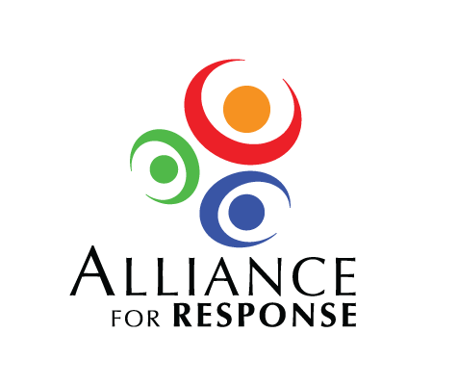

Dear :

It was a pleasure to meet you at , and I am glad you could spend the day with us at the Alliance for Response Forum. We are grateful to you and to for agreeing to sponsor the food and refreshments at the meeting. The lunch was excellent, and it provided such a good opportunity for participants to become better acquainted.

has received and paid the final catering bill from for the Forum breakfast, lunch, and afternoon beverage break. Copies of the bill, which totaled $, and our check are enclosed.

The response to the Forum has been very positive, and there is interest in sustaining the dialogue begun . I hope you will continue to be involved in any initiatives that develop in the area.

Sincerely,