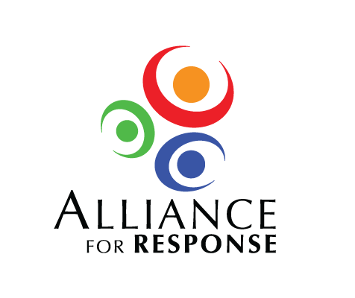

Dear :

We are grateful that you could take part in the recent Alliance for Response Forum in . Your presentation beautifully illustrated the wealth of cultural and historic resources in the area, and the effects of provided a timely reminder of the risks to those treasures.

The response to the Forum has been enthusiastic, and there is keen interest in sustaining the dialogue begun . I hope you will continue to be involved and lend your considerable expertise.

Many thanks for your special contribution to the Forum.

Best regards,