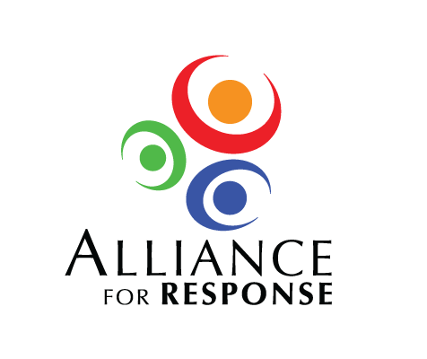

**Alliance for Response Forum**

**Talking Points for Speakers**

The Planning Committee extends its thanks to each of you for taking the time from your busy schedules to speak at the upcoming Forum. We suggest the following talking points to ensure that all the essential themes will be addressed during the course of the day. We’re sending this to all the speakers to provide context and email addresses in case panelists wish to contact one another before the conference. If you have any questions, please do not hesitate to contact .

**9:00-9:15 am Welcoming Remarks**

5 minutes each introduction. To establish local context, please say a few words about the uniqueness and valuable cultural resources in . If you each focus on your area of expertise (i.e. museums, archives, libraries) it should give the audience a broad idea of the richness of collections in institutions.

**9:15-9:30 am Protecting Our Cultural Heritage: Why it Matters**

This talk sets the philosophical context for the entire Forum. The key points we would like you to address are as follows:

* Why cultural property should be protected
* The importance of cultural heritage in documenting our past
* The value of cultural assets: (monetary, value in the context of history, value in terms of psychological and emotional enrichments, value to the economy (e.g., tourism))
* Importance of disaster planning
* Necessity of being familiar with and collaborating with emergency management services at all levels

**9:30-10:45 am Panel: Planning for the Aftermath and Working with First Responders**

The purpose of this panel is to inform the cultural community about how the emergency management system works. Please avoid using acronyms and jargon without explanation. Because there is so much to cover, please remember that each panelist has only 15 minutes to bring your topic into focus. The moderator will have about 15 minutes to provide an introduction, and lead a 10-15 minute Q&A session following the presentations.

**Moderator:**

Introduce the panelists, provide context for the discussion (15 minutes), and lead a 15 minute Q&A session after the speakers present.

* Please provide a brief overview of FEMA and how FEMA works with state and local emergency management agencies in the event of a federally declared disaster.
* Explain FEMA’s role in terms of what it can and can’t do to help cultural institutions.
* Please describe any proposed changes or revisions to FEMA’s cultural policy post-Katrina, etc.

**Panelists:**

Your focus is on state efforts in mitigation and response. Your talk will also set the stage for the narrowing focus of the 2 speakers who follow. Please include the following in your remarks:

* Provide a brief description of and it’s relationship with Federal and local emergency management
* Help the audience understand resources and its role in the community
* Describe the steps has taken to prepare industry, business, schools, government, etc. for emergencies
  + Discuss the need to transfer the experience derived from these preparations and apply it to cultural institutions
* Stress the importance of cross-pollination between the cultural community and the emergency management community

As a speaker representing , please briefly review the major risks affecting the area – hurricanes, sever weather, ice storms, tornadoes, terrorism, etc. Please plan to cover the following:

* Probability of events occurring, and the urgency for institutions to undertake risk assessment, planning, and mitigation
* Role of – what it can and can’t do to help cultural institutions
* “Cross-pollination” at the national and regional levels – examples of how has worked successfully with the cultural community (museums, libraries, archives, etc.)

Moving from broad to specific, please address issues at the institutional level. Including:

* Review the types of emergencies a fire department typically responds to
* Address how a cultural institution can cooperate with first responders before or during a disaster (i.e. a fire) to minimize damage to its collection
* What your department needs to know about a cultural institution before a disaster
* How would you respond to a fire in a cultural institution as opposed to a fire in an office building, for example
* Brief description of CERT or other training that might be advantageous for staff from the cultural community to obtain

**11:00 am – 12:00 noon Panel: When the Worst Happens**

**Moderator:**

Introduce the panelists, provide context for the discussion, and lead a 15 minute Q&A session after the speakers present.

**Panelists:**

Lessons Learned from Hurricane Katrina

Discuss damage to cultural institutions during in . Start with a brief synopsis of the initial event, then view the incident with 20/20 hindsight:

* What would you do differently now?
* What resources were used, and what other resources would have been valuable at the time?
* How would more effective communication/cooperation between the cultural community and the emergency management community have been helpful?
* What new measures/procedures have been implemented since the incident, i.e., since having worked with first responders and emergency personnel?

You will provide an important case study of a recent disaster, the . Start with a brief synopsis of the initial event, then view the incident with 20/20 hindsight:

* What would you do differently now?
* What resources were used, and what other resources would have been valuable at the time?
* How would more effective communication/cooperation between the cultural community and the emergency management community have been helpful?
* What new measures/procedures have been implemented since the incident, i.e., since having worked with first responders and emergency personnel?

**1:00- 1:30 pm Developing Local and Regional Disaster Networks**

Your presentation will describe a successful model for regional and statewide disaster planning.

* Description of these networks and how they originated. (structure, focus, mission)
* Describe similar organizations if they exist
* Suggest steps we might take in to form something similar