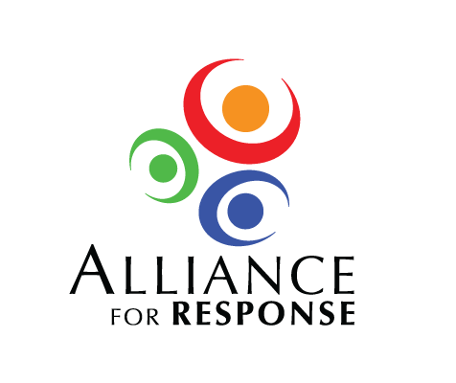

Dear :

Thank you for agreeing to speak at the Alliance for Response Forum, to be held , at . Alliance for Response is an initiative of the Foundation of the American Institute for Conservation and hosted by the . The program has been developed by a distinguished local committee.

The invitation-only Forum will bring together cultural heritage leaders, senior emergency management professionals, and first responders from the greater area. The day-long program is designed to strengthen the relationships between cultural institutions, emergency managers, and first responders. We hope to .

We are pleased that you have agreed to speak at the Forum. We would like you to speak about . Please plan your comments for between on .

The planning committee will be happy to provide you with further information to help you craft your presentation. A draft agenda for the Forum is enclosed, along with information on the Alliance for Response Planning Committee and the Alliance for Response project. Please do not hesitate to contact me, or members of the local committee, with any questions you might have.

We are grateful for the special contribution you will make to the Forum in , and we look forward to working with you.

Sincerely,