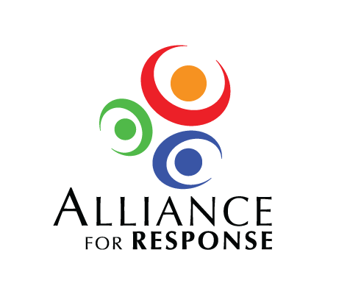

Dear :

Museums, libraries, and archives in hold in trust the art, historic artifacts, and records that are the community’s cultural heritage. But often, the stewards of local treasures are inadequately prepared for disasters, and local emergency personnel are unaware of the collections’ special value to the community.

**Alliance for Response,** an initiative designed to help cultural institutions work more closely with the emergency management community, was begun in 2003 and has resulted in Forums held in over 30 cities and regions in the United States. The Forums are high-profile events that raise awareness of the need to protect cultural and historic resources in communities and to develop strong local response networks. Participants include leaders of museums, libraries, archives, and historic preservation organizations, as well as state and local officials and first responders.

A local committee in , led by , has planned an excellent Forum for at . I am enclosing an invitation, roster for the local committee, and preliminary program for the Forum.

We invite you to support this important program by sponsoring the Forum lunch at the . We request $ to cover the cost of lunch for participants. Your generous contribution will be gratefully acknowledged at the Forum and in meeting materials, and you would be most welcome to display information about your company’s services. While the national Alliance for Response initiative has been supported by the National Endowment for the Humanities, local support has been important to all the Forums.

We have extended an invitation to to attend the Forum, and we would warmly welcome your participation.

I look forward to hearing from you and appreciate your considering our request.

Sincerely,