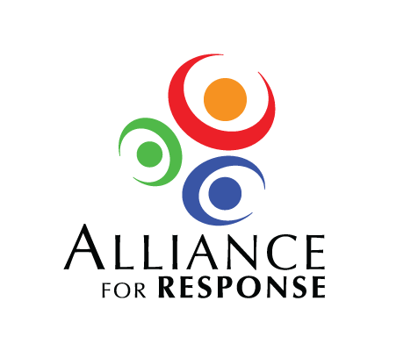**Alliance for Response**

8:30 - 9:00 **Registration and Breakfast**

9:00 - 9:15 **Welcoming Remarks**

Director of

9:15-9:30 **Protecting Our Cultural Heritage: Why It Matters?**

9:30– 10:45 **Panel Discussion: Planning for the Aftermath & Working with First Responders**

Moderator: Representative from FEMA

* + - * Representative from State Emergency Management Agency
      * Representative from County Emergency Management
      * Representative from City Fire Department

10:45 – 11:00 Break

11:00 - 12:00 **Panel Discussion: When the Worst Happens**

Moderator: Planning Committee Member

* + - * Director, State Archives
      * Executive Director, City Museum
      * Director, University Libraries

12:00 – 1:00 Lunch

1:00 – 1:30 **Developing Local and Regional Disaster Networks**

1:30 – 1:45 **Steps to Partnerships: Overview of Current Initiatives**

1:45 - 2:30 **Break Out Sessions: Where Do We Go from Here?**

* + - * Incorporating cultural and historic resources into local plans
      * Building cultural heritage and response teams
      * Forming a area network that could serve as a model for other parts of the state.

2:30 - 3:00 **Closing Remarks**