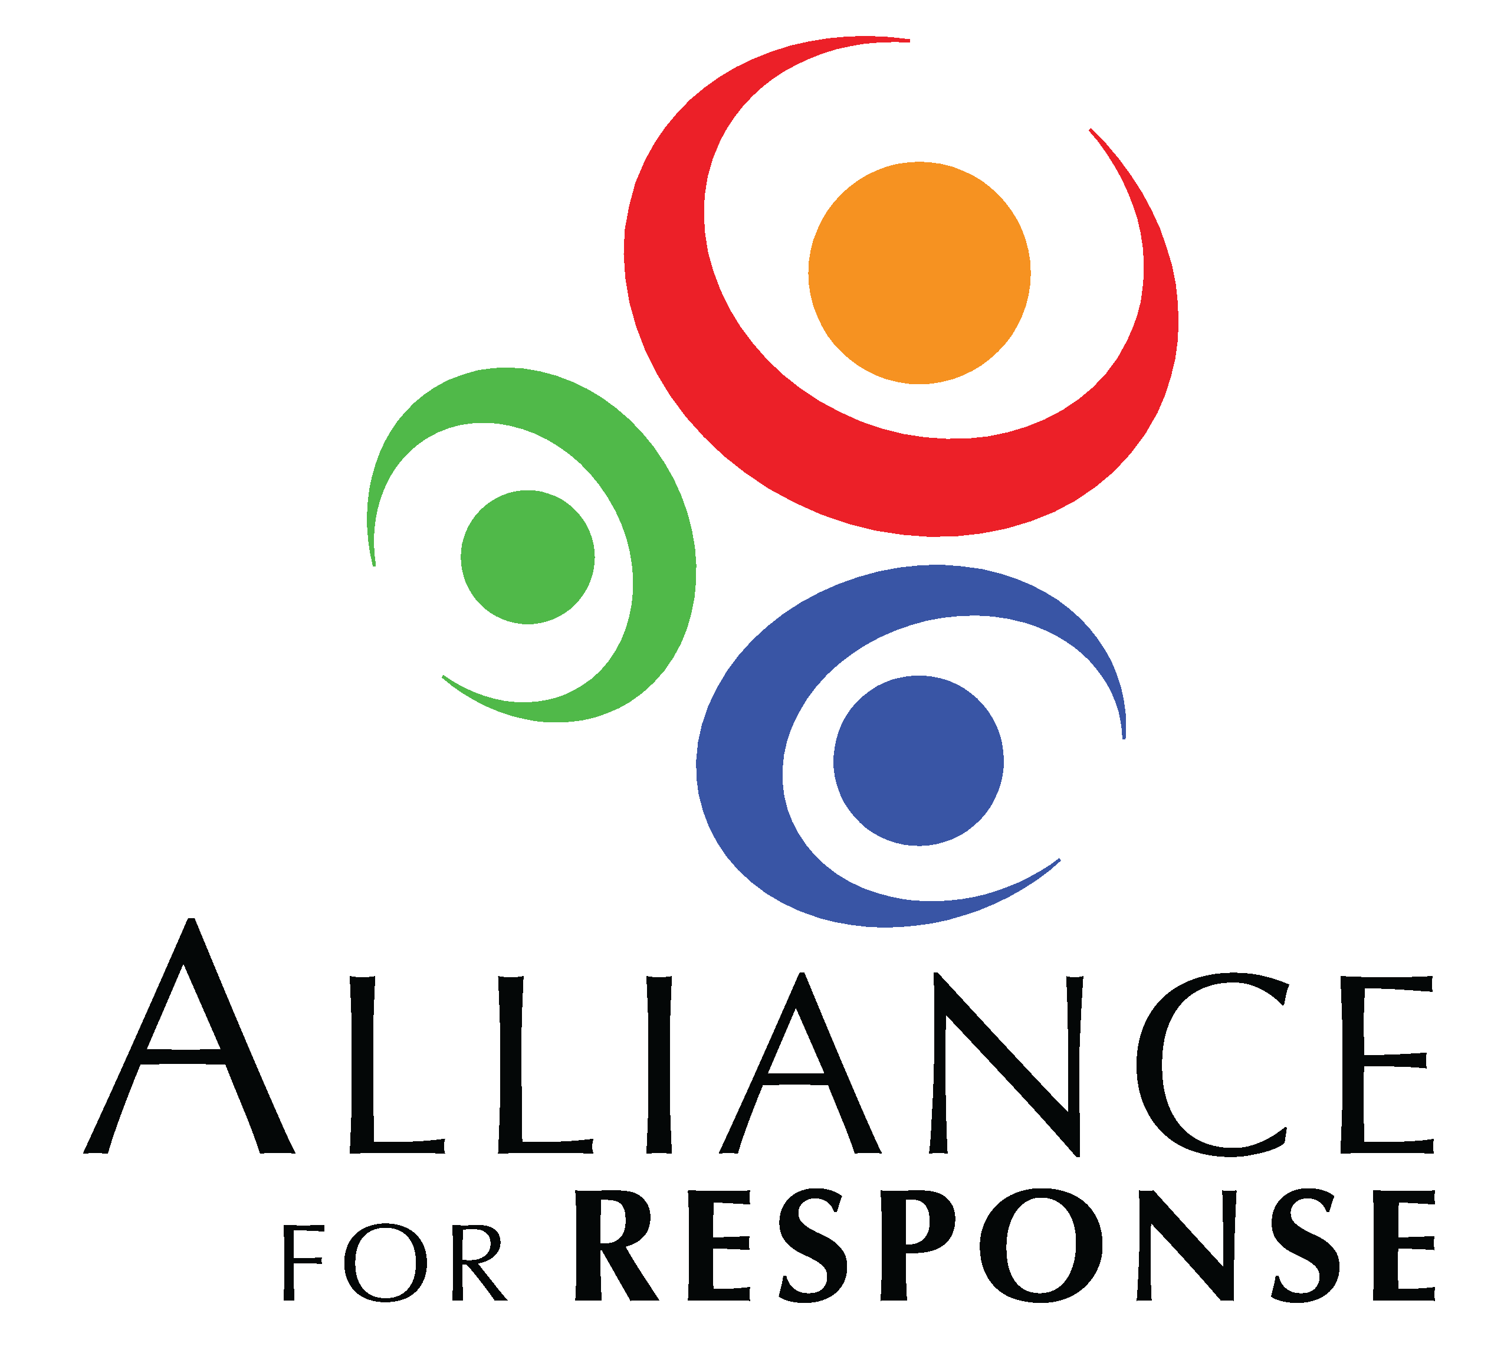
Pre-Forum Checklist

SPEAKERS

___ Provide speakers with adequate background on the goals of the meeting
___ Request an outline from each speaker of key points he or she will make
___ Request in advance brief biographies of the speakers
___ Schedule a conference call for all speakers or by panels
___ Reconfirm the amount of time allotted for each presentation
___ Reconfirm A/V needs
- Request presentations in advance to load onto computer
- Ask speakers to also bring presentations on thumb drives
___ Give speakers a deadline and an address for shipping handout materials
___ Let speakers know how you plan to handle Q-and-A. Will you:
- Invite questions after each speaker or at the end of each session?
- Assign a moderator to field and direct questions?
___ Inform the speakers
- What time you want them to arrive the day of the Forum
- Who will introduce them
- How you will keep time during presentations
___ Develop a discussion outline with people leading breakout groups and the wrap-up session

PARTICIPANTS

___ One week to 10 days before the Forum, send participants an e-mail to:
- reconfirm attendance, especially if they did not receive an automatic message after registering
- provide logistical information on the location’s entrance, parking, etc.
- encourage them to invite and register a colleague or local emergency professional, if space is still available

MEETING MATERIALS

Meeting folders should contain:

___ Final Alliance for Response Forum Agenda
___ Biographies of speakers
___ Participant roster
___ Acknowledgement of planning committee and sponsors
___ Alliance for Response brochure (copies provided by Heritage Preservation)
___ Evaluation Form (master document from HP)
___ Guide to Acronyms (master document from HP)
___ Alliance for Response Follow-up Project Examples (master doc from HP)

Materials for Meeting Folders or Resource Table:
___ “Working with Emergency Responders” Poster (provided by HP)
___ Disaster Response Networks List (master document from HP)
___ Flyer on Heritage Preservation free resources (provided by HP)
___ Flyer on Heritage Preservation’s Wheel and Field Guide (provided by HP)
___ “Preparing to Preserve” historic preservation checklists (provided by HP)
___ Other resource information provided by sponsors or speakers

ROLES, CONTACT INFO FOR STAFF AND VOLUNTEERS ON FORUM DAY

Meeting Task Staff Cell

Registration Table _______________________ _________________
Resource table(s) set-up ________________________ _________________
Speaker Liaison(s) ________________________ _________________
A/V Technical Issues ________________________ _________________
HVAC and lighting ________________________ _________________
Catering arrangements ________________________ _________________
Photographer ________________________ _________________
Media relations ________________________ _________________
Escorting breakout groups ________________________ _________________
Collecting evaluation forms ________________________ _________________

