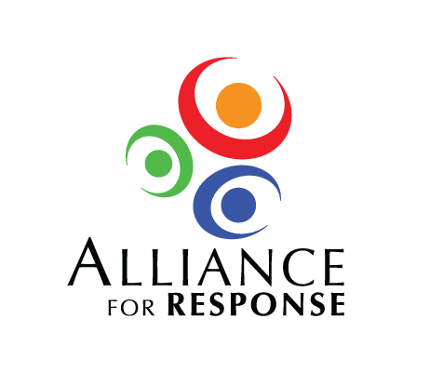
Planning Guide – Alliance for Response

Planning Committee
- Determine members, invite participation
- Create and share a committee roster including contact information
- Determine frequency and format of meetings –
- Determine a budget for the conference. Expenses to consider include
  - Speaker travel reimbursement
  - Refreshments (breaks, lunch)
  - Any charges for the venue, including audio-visual support
  - Mailing costs for invitations
  - Duplication costs for conference materials

Venue and Dates
- Make sure that dates don’t conflict with other museum/library conferences
- Find a venue that has
  - Space to accommodate breakout sessions
  - Space for refreshments for breaks and lunch
    - If lunch is not provided, are restaurants close, and can they accommodate the number of participants anticipated?
  - Adequate parking facilities
    - If there is a charge for parking, participants will need to know in advance
    - Can vouchers be negotiated? How will these be distributed?
  - Registration table and space for handouts
    - handouts from several speakers in addition to the conference folders
- Other considerations for venue
  - Does the venue have a laptop or computer at the podium, internet connections, projector, sound equipment, or will you need to provide equipment? Be sure to share this information with speakers
- For a statewide conference, will some speakers and/or participants need to stay overnight? Is there a reasonably-priced hotel near the venue? If so
  - Arrange a room block and conference rate if possible

Conference Agenda/Speakers
- Determine topics to be covered
- Determine who will serve as conference moderator(s)
- Identify potential speakers (good to have back-ups, as well)
  - Determine who from the planning committee will issue invitations
  - Timeline for issuing invitations
  - If there will be breakout groups, who will facilitate? Planning committee members? Speakers?
- Once speakers are confirmed
  - Send confirmation letters, including details on expense reimbursement and hotel information if appropriate
  - Create and provide scope notes for each speaker
    - For panel discussions, it can be helpful to set up a conference call to bring all the speakers together to coordinate presentations, themes, etc.
  - Develop discussion guides and facilitation expectations for breakout group facilitators
- Speaker logistics
  - Deadlines for submitting handouts, PowerPoint presentations
    - Will speakers need special equipment (i.e., internet connectivity?)
    - Will all presentations be loaded onto one laptop, or should speakers bring their own?
  - Speaker bios for inclusion in conference packet and to use in introducing speakers

Invitations/Communications with Participants
- Hold the date message – send as soon as date/venue are confirmed
- Invitation with agenda – mail and e-mail
- Reminder to register with agenda – sent approximately 2 weeks prior to deadline
- Participant information (sent via e-mail)
  - Confirmation of registration (send when registration is received), including hotel information, what meals are provided, and other logistics if appropriate
  - Directions, final agenda, and logistical information (send approximately 1 week prior to conference)

Conference Packet Contents
- Agenda
- Speaker Bios
- Participant Roster
- PowerPoint presentations and handouts
- Instructions for breakout sessions
- Evaluation

Conference Wrap-up
- Compile evaluations and share with planning committee
- Create final report
  - Include action plans for future
  - Share with speakers and participants
- Start planning for next conference

