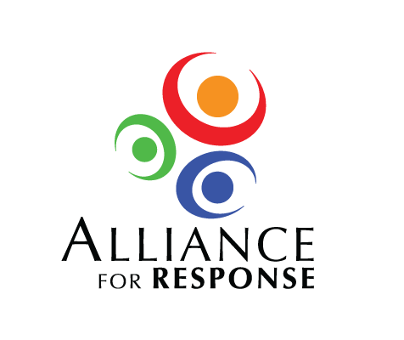

Dear :

We would be delighted if you would participate at the Alliance for Response Forum on the at the . The invitation-only meeting will bring together leaders of ’s museums, libraries, archives, and historic sites with the emergency professionals who help protect their institutions.

Alliance for Response is an initiative of the Foundation of the American Institute for Conservation (FAIC). We are fortunate to have an excellent local Steering Committee with members from [INSTITUTION] and [INSTITUTION]. They have planned an excellent program. Topics will focus on building alliances at every level – relations with the emergency management community, as well as internal cooperation among preservation, operations, and risk management departments. The forum will include remarks from [OTHER SPEAKERS]. We hope that you will take part, too.

A flyer on the Alliance for Response program is enclosed. Please do not hesitate to contact me for further information.

I look forward to hearing that you will join us on at the .

Sincerely,