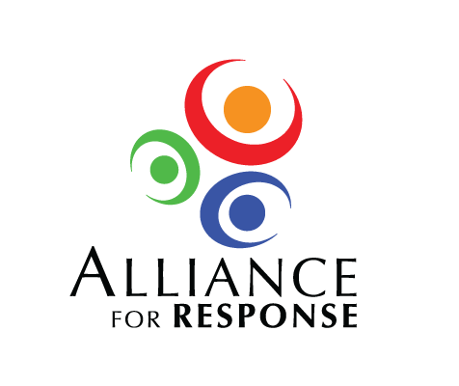

**Forum Evaluation**

**1. How would you best describe your organization?**

❒ Archive ❒ Law Enforcement Agency ❒ Grant Maker ❒ Business

❒ Library ❒ Emergency Management Agency ❒ Fire/EMS Department

❒ Museum ❒ Arts, Cultural, or Historical Agency ❒ Service Organization ❒ Other__________

**2. What type of organization is it?**

❒ Municipal ❒ State ❒ Non-profit 501(c)(3) ❒ Corporation

❒ County ❒ Federal ❒ College or University ❒ Other______________________

**3. Please rate your change in knowledge in the following areas as a result of participating in this Forum.**

|  |  |  |  |  |
| --- | --- | --- | --- | --- |
|  | **No gain** | **Some gain** | **Big gain** | **Don’t know** |
| Principles of disaster planning and response |  |  |  |  |
| Available resources for planning & mitigation |  |  |  |  |
| Structure and protocol of local emergency management |  |  |  |  |
| Significance of local cultural resources |  |  |  |  |
| Special considerations of cultural institutions during emergencies |  |  |  |  |
| Cooperating with emergency responders and cultural institutions on disaster projects |  |  |  |  |

**4. What new facts or ideas will you take from this meeting to share with your colleagues?**

**5. What parts of the program were of the most interest to you? Why?**

**6. What new contacts made today will be of particular value to your institution or agency?**

**7. Do you anticipate collaborating with your local emergency management/response agencies and/or cultural institutions as a result of information presented or contacts made at this Forum?**

**8. What are the most urgent steps for your organization in terms of disaster preparedness?**

**9. Would you like to be involved in continuing cooperative disaster efforts in this region? If yes, please provide your name and contact information.**