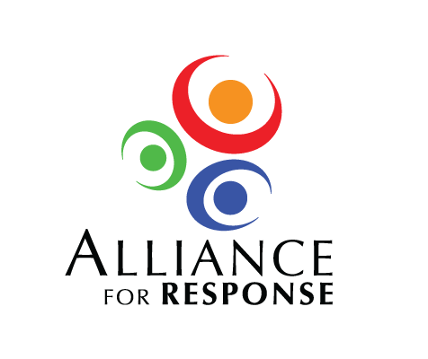

On behalf of the Planning Committee for the Alliance for Response Forum I would like to extend an invitation to you to participate in the Forum, which will be at the in on . It will be an invitation-only all day event with lunch included. A draft program is attached and the following provides some additional information.

The Alliance for Response will bring together representatives of cultural institutions and emergency managers and first responders to:

There's more information about Alliance for Response at:

[www.heritageemergency.org/afr](http://www.heritageemergency.org/afr)

We'll send out a formal invitation with information on registering later this spring, but this is to get the date on your calendar. Please let me or another member of the Committee know if you have questions. We hope you can come.

Sincerely,

ALLIANCE FOR RESPONSE PLANNING COMMITTEE