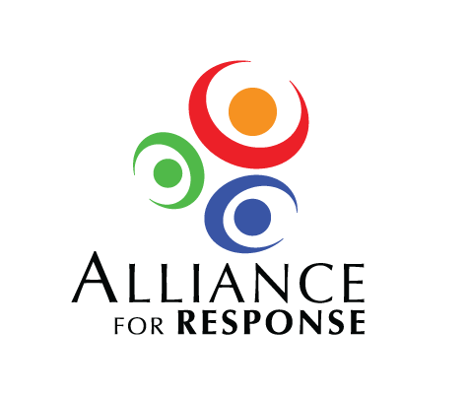

Breakout Session Worksheet

|  |
| --- |
| Breakout Topic 1 |
| Cultural and Historic Institution Professionals: A Place in the Emergency Operations Plan |
| Key Actions/Components |
|  |
| Support or Involvement Needed |
| *From cultural institutions*        *From emergency responders*        *From other sources* |
| Next Steps |
|  |

Breakout Session Worksheet

|  |
| --- |
| Breakout Topic 2 |
| Building Cultural Heritage Response and Recovery Teams |
| Key Actions/Components |
|  |
| Support or Involvement Needed |
| *From cultural institutions*        *From emergency responders*        *From other sources* |
| Next Steps |
|  |

Breakout Session Worksheet

|  |
| --- |
| Breakout Topic 3 |
| Sharing Resources: Emergency Supplies and Trained Personnel |
| Key Actions/Components |
|  |
| Support or Involvement Needed |
| *From cultural institutions*        *From emergency responders*        *From other sources* |
| Next Steps |
|  |

Breakout Session Worksheet

|  |
| --- |
| Breakout Topic 4 |
| Mobilizing a Response Team to Help Recovery Efforts in Other Regions |
| Key Actions/Components |
|  |
| Support or Involvement Needed |
| *From cultural institutions*        *From emergency responders*        *From other sources* |
| Next Steps |
|  |