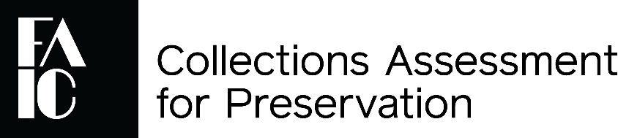

**Certification of Authorizing Official**

I am a member of the Board of Directors or Governing Body, or the Government Official responsible for oversight of the organization, and am authorized to submit this application to the Collections Assessment for Preservation program. I certify that all of the information contained in this application is true and accurate to the best of my knowledge. Should our organization be chosen to participate in the program, our staff will be responsible for complying with all requirements and guidelines of the Collections Assessment for Preservation program, including:

* Participating in the CAP program orientation
* Selecting and contracting assessor(s)
* Completing the Site Questionnaire
* Facilitating and participating in the pre-visit phone call with assessor(s)
* Facilitating assessors’ site visit
* Reviewing CAP report draft
* Completing program evaluations
* Facilitating a one-year follow-up call or videoconference with assessor(s)

**Signature of Authorizing Official: _______________________________ Date:** ____________

Please fill in the information below.

🞐 Mr. 🞐 Ms. 🞐 Miss 🞐 Mrs. 🞐 Dr. 🞐 Prof 🞐 Rev

Name: ____________________________________ Title: _______________________________

Phone: ___________________________ E-mail: ______________________________________

**CAP is presented under a cooperative agreement with:**

