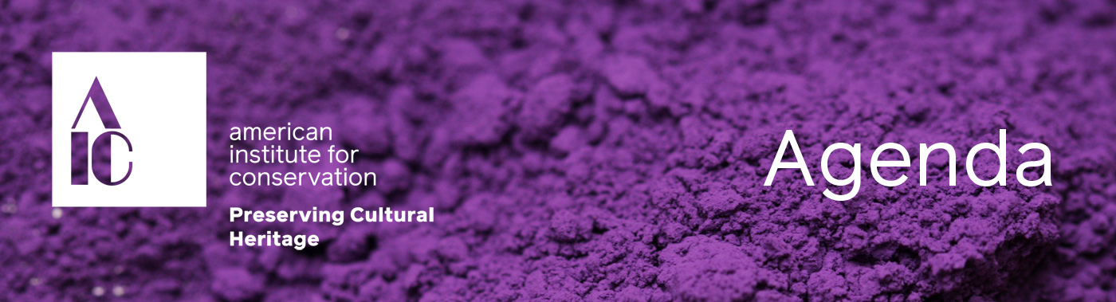

**Volunteer Orientation**

**Zoom Webinar**

**Date:** September 29, 2021

**Time:** 1:00 p.m. ET

**Location:** Zoom Webinar

Led by Bonnie Naugle, AIC Communications & Membership Director

1. Welcome (Eryl Wentworth)
2. Organizational Overview
   1. Leadership Structure
   2. Types of Volunteer Groups
   3. Board Members & Responsibilities
   4. Staff Members & Responsibilities
3. General Timelines
   1. Calendars
   2. Budget Schedule
   3. Annual Meeting Schedule
   4. Volunteer Cycle
   5. Membership Schedule
   6. Education and Funding Timelines
4. Responsibilities & Opportunities (Various Staff and Editors)
   1. AIC News (Lisa Goldberg)
   2. Wiki/Websites (Rachael Arenstein)
   3. Officer Responsibilities (Erika Goergen and Ryan Winfield)
   4. Communications
   5. Annual Meeting (Ruth Seyler)
   6. Funding (Sarah Saetren)
   7. Professional Development (Sarah Saetren)
   8. Surveys and Polls (Ryan)
   9. Recordkeeping (Erika)
   10. Outreach & Programming
5. Contacting Us
6. Navigate Our Online Resources
   1. Guided tour
   2. Instructions for personalization
7. Q&A