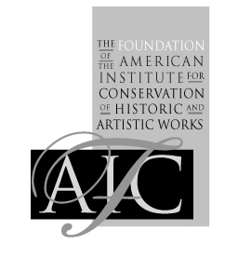

The Foundation of the American Institute for Conservation of Historic & Artistic Works

Media Consolidation for Ancient and Medieval Manuscripts on Parchment
Workshop Application Form

First name: Last name:
Street Address:
City, State, Zip, COUNTRY:
Phone: E-mail:
Position Title: Institution:
Membership Status:
Associate member
AIC Professional Associate member
AIC Fellow member
AIC Student member
Non-AIC member
Other

Be sure to attach:
Resume or C.V.
Statement addressing the selection criteria
Workshop selection criteria can be found at http://www.conservation-us.org/parchment

Send this form with your statement and resume or C.V. as an email attachment to
courses@conservation-us.org
or, by mail to:
FAIC
Attn: Parchment Workshop Application
1156 15th Street NW, Suite 320
Washington, DC 20005-1714
The Foundation of the American Institute for Conservation of Historic and Artistic Works
1156 15th Street, NW • Suite 320 • Washington, DC 20005 • Phone: (202) 452-9545 • Fax: (202) 452-9328
E-mail: courses@conservation-us.org • Web site: http://www.conservation-us.org

