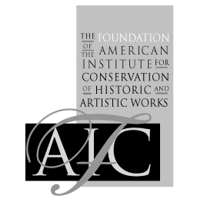

The Foundation of the American Institute for Conservation of Historic & Artistic Works

Platinum and Palladium Photographs –Workshop Application Registration & Payment
First name: Last name:
Street Address:
City, State, Zip, COUNTRY:
Phone: E-mail:
Position Title: Institution:
Membership Status:
AIC member - $220
Non-AIC member - $320

Indicate which session you have been assigned for the workshop, if selected:
ONLY October 21
ONLY October 24
You must register for the Symposium (October 22-23) to attend the workshop.
Credit Card
Name on card:
Card Number:
Expiration Date:
3-digit Security Code:
Check
Mail to:
FAIC
Attn: Platinum Palladium Registration
1156 15th Street NW, Suite 320
Washington, DC 20005-1714
Wire
Institute Name: Foundation of the American Institute for Conservation of Historic & Artistic Works
Name of the Bank: Wells Fargo
Bank account: 2000020773014
Swift/Bic: WFBIUS65
ABA routing: 121000248
The Foundation of the American Institute for Conservation of Historic and Artistic Works
1156 15th Street, NW • Suite 320 • Washington, DC 20005 • Phone: (202) 452-9545 • Fax: (202) 452-9328
E-mail: courses@conservation-us.org • Web site: http://www.conservation-us.org

