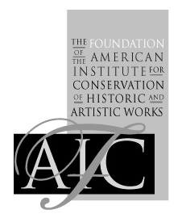

**Foundation of the American Institute for Conservation of**

**Artistic & Historic Works**

## Instructor Evaluation Form

# I. Event Information

|  |  |
| --- | --- |
| Instructor’s Name |  |
| Name of Event |  |
| Date Taught |  |
| Location of Event |  |

# II. Course Structure

1. What parts of the program seemed to work well for participants? What would you change in the future?

# III. Participants

1. Was the number of participants appropriate for this workshop?

2. Were the participants prepared to work at the level you anticipated? If not, what pre-requisites would you recommend in the future?

3. Would you have preferred to see a different mix of skills or training among the participants? If so, please describe.

# IV. Facility

1. Was the facility suitable for this event? What worked? What didn’t?

# V. Materials and Supplies

1. Did you have all necessary equipment and materials to conduct this workshop?

2. Were handouts or notebooks copied and prepared to your satisfaction?

# VI. Promotion

1. Did there seem to be a match between participants’ expectations and what you presented?

2. Do you have any suggestions for other ways to advertise or promote this event in the future?

# VII. Administration

1. Did the local liaison or other on-site staff provide the support you needed?

2. Did you encounter any difficulties or surprises in dealing with FAIC staff?

3. Were payments and reimbursements handled to your satisfaction?

# VIII. Future Events

1. How could this event be improved if offered again in the future?

2. What other professional development events would you recommend be offered by FAIC in the future (by you or by other instructors)?

*Please return this form to FAIC office or E-mail to courses@conservation-us.org*