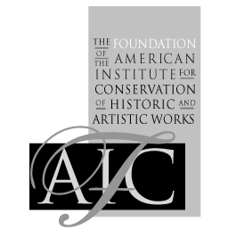
The Foundation of the American Institute for Conservation of Historic & Artistic Works

TechFocus III: Caring for Computer-Based Art Registration Form

First name: Last name:
Street Address:
City, State Zip:
Country:
E-mail:
Institution (if any): Title:
Registration:
AIC member regular Registration - $180
Non-AIC member regular Registration AIC member- $250
Student regular Registration - $80*

AFTER August 20, 2015 - Late Registration Fee:
AIC member regular Registration - $200
Non-AIC member regular Registration AIC member- $300
Student regular Registration - $100*

*You must provide evidence of your student status to qualify for this price.
Credit Card
Credit card type (Visa, MasterCard, Discover, American Express):
Name on card:
Card Number:
Expiration Date:
Check
Mail to:
FAIC
Attn: TechFocus III: Registration
1156 15th Street NW, Suite 320
Washington, DC 20005-1714
Wire
Institute Name: Foundation of the American Institute for Conservation of Historic & Artistic Works
Wells Fargo
1510 K Street, NW, Washington, DC
SWIFT code: WFBIUS6S
IBAN Number: 121000248 2000020773014
Send this form as an email attachment to courses@conservation-us.org
mail to: FAIC at 1156 15th St., NW, Suite 320, Washington, DC 20005, or fax to: 202-452-9328

The Foundation of the American Institute for Conservation of Historic and Artistic Works
1156 15th Street, NW • Suite 320 • Washington, DC 20005 • Phone: (202) 452-9545 • Fax: (202) 452-9328 •
E-mail: courses@conservation-us.org • Web site: http://www.conservation-us.org

